Reversive Antonyms

🔹 What is Reversive Antonyms
# Source: AI Source: Provided by: [Data Path: Persons Table -> ID Column: 1, Name_En Column: Motasem Essam] -> From: [Chatgpt (GPT-4-turbo)] on [7/30/2025]
Reversive antonyms are verb pairs where one verb undoes the action of the other. They describe reversible processes or actions — doing one results in a state that can be reversed by doing the other.

🧠 Definition:
# Source: AI Source: Provided by: [Data Path: Persons Table -> ID Column: 1, Name_En Column: Motasem Essam] -> From: [Chatgpt (GPT-4-turbo)] on [7/30/2025]
Reversive antonyms are pairs of words (often verbs) where one represents an action that can be reversed or undone by the other.

📌 Key Characteristics:
# Source: AI Source: Provided by: [Data Path: Persons Table -> ID Column: 1, Name_En Column: Motasem Essam] -> From: [Chatgpt (GPT-4-turbo)] on [7/30/2025]
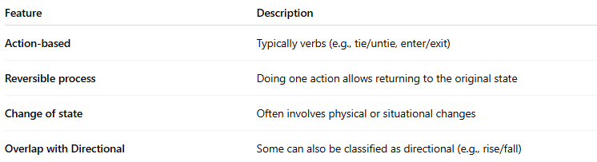
Feature | Description
Action-based | Typically verbs (e.g., tie/untie, enter/exit)
Reversible process | Doing one action allows returning to the original state
Change of state | Often involves physical or situational changes
Overlap with Directional | Some can also be classified as directional (e.g., rise/fall)

📚 Examples of Reversive Antonym Pairs:
# Source: AI Source: Provided by: [Data Path: Persons Table -> ID Column: 1, Name_En Column: Motasem Essam] -> From: [Chatgpt (GPT-4-turbo)] on [7/30/2025]
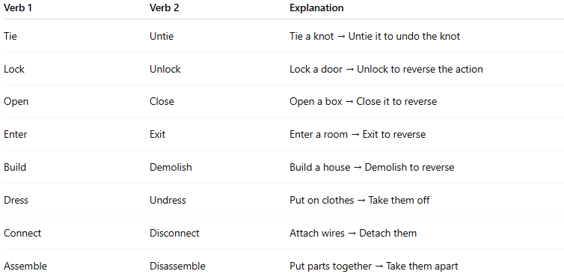
Verb 1 | Verb 2 | Explanation
Tie | Untie | Tie a knot → Untie it to undo the knot
Lock | Unlock | Lock a door → Unlock to reverse the action
Open | Close | Open a box → Close it to reverse
Enter | Exit | Enter a room → Exit to reverse
Build | Demolish | Build a house → Demolish to reverse
Dress | Undress | Put on clothes → Take them off
Connect | Disconnect | Attach wires → Detach them
Assemble | Disassemble | Put parts together → Take them apart

✏️ In Context:
# Source: AI Source: Provided by: [Data Path: Persons Table -> ID Column: 1, Name_En Column: Motasem Essam] -> From: [Chatgpt (GPT-4-turbo)] on [7/30/2025]
- He locked the door before leaving, but she unlocked it later.
- After assembling the toy, we had to disassemble it for storage.

🔁 Comparison with Other Antonym Types:
# Source: AI Source: Provided by: [Data Path: Persons Table -> ID Column: 1, Name_En Column: Motasem Essam] -> From: [Chatgpt (GPT-4-turbo)] on [7/30/2025]
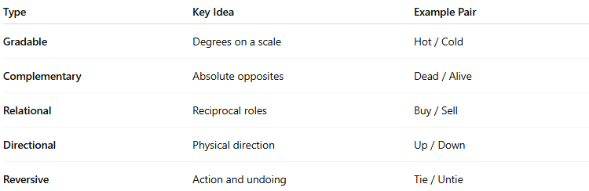
Type | Key Idea | Example Pair
Gradable | Degrees on a scale | Hot / Cold
Complementary | Absolute opposites | Dead / Alive
Relational | Reciprocal roles | Buy / Sell
Directional | Physical direction | Up / Down
Reversive | Action and undoing | Tie / Untie

